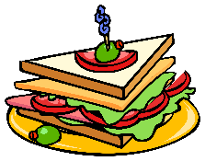


Come and meet your local community groups

Find out what’s going on in and around the Golden Valley

Discover what support is available for existing and prospective groups

Join us for soup, sandwiches, a hot drink and cake


www.Golden Valley Groups.uk
Ewyas Harold Memorial Hall
Sunday 18th November 2018
10 am to 4 pm
Entrance Free

Discover Community Groups, Social Activities & Charities, in and around the Golden Valley
See
Be Seen

Let others know What you do, Where and When you do it and How they can join you
Societies Fair

